Making sense of composition

If there is one aspect of picture-making that distinguishes the trained, professional painter from the able amateur, it is composition. Despite the wealth of information available on the subject in books and online, it’s not so easy to find a description of a coherent, practical method of composing a painting.

What exactly is composition? A working definition might be ‘a visually pleasing arrangement of the pictorial elements of a painting’. Examples of pictorial elements are line, value and colour. ’A visually pleasing arrangement’ would be the result of organizing the elements according to the set of established design principles which include balance, rhythm, proportion and unity. These principles and elements of design will be discussed later.

If your preference is for abstract, non-representational art, then composition is pretty much an exercise in pure design, as defined above. For the figurative or representational painter, however, there is an additional consideration: his subject matter.

Subject matter and pictorial elements are not the same thing. Pictorial elements are, if you like, the atomic structure of the painting, while subject matter is the large scale organization of these elements. We can go further: the elements can be arranged freely, without restriction. They are, in effect, abstractions. Subject matter, on the other hand, is a representation of reality and, at least in naturalistic works, must conform to our expectations of its behavior in the real world. The figure, for example, conforms to the constraints of its anatomy; it’s also constrained by the laws of perspective. The problem for the figurative artist is to compose his painting while observing these constraints. This is no easy task. It inevitably involves some degree of compromise between fidelity to the subject matter and the purity of the overall abstract design.

Naturalism introduces two other compositional complications: the first is the illusion of depth in a painting; the second is the suggestion of volume through the consistent modelling of forms.

Linear perspective is a powerful tool for creating the illusion of real 3D space while aerial perspective suggests the deep space of the landscape. Both have implications compositionally in that they restrict the choice of certain elements – value and colour in the case of aerial perspective, value and shape in linear perspective. In addition, because they introduce the illusion of depth, they affect movement in the work – that is, the path the eye takes through the composition. Depth cues exert a strong influence on movement and may create ‘holes’ in the design, leading the eye away from the intended focal point.

Modelling of form is the suggestion of volume by means of changes in value or tone; it’s really a special case of the illusion of depth. (Form is a confusing term: in sculpture, it refers to the three-dimensional structure of an object; here, in painting, it refers to the two-dimensional representation, i.e. the shape, of a three-dimensional object such as the human figure.) Consistent modelling of the forms in a painting will imply a light source or sources. This is a fundamental device in naturalistic, representational art. The illusion of volume, however, comes at a price in terms of compositional freedom: the colour, value and shape of shadows, for example, will all be constrained.

In the description of the compositional methods which follows, I’ve used examples of my own work to illustrate and investigate various points. There is some merit in doing it this way rather than using paintings by other artists because I know how much deliberate compositional planning went into each piece.

I’ll look at three popular approaches to composition:

- the ‘rule of thirds’
- notan
- elements and principles of design

rule of thirds

I remember reading about the Rule of Thirds in connection with photography back in the 1970s. According to Wikipedia, its origins go back to the end of the eighteenth century when John Thomas Smith proposed the idea as a useful compositional rule of thumb for landscape painters.

It’s quite simple to use. Divide the edges of the support into thirds and use the points to create a regular grid. Smith’s original account stressed the importance of the two-to-one ratio in good composition. Thus, in a landscape painting, he recommends one-third land and two-thirds sky or two-thirds land and one-third sky – but never a 50/50 split. The grid makes it easy to observe these proportions both in the horizontal and vertical planes. The four points of intersection of the grid lines are particularly important because the eye is naturally attracted to these areas. Putting significant content at one of these points exploits this apparent property of the grid and creates a focal point.

Does the Rule of Thirds work? Here are some examples,

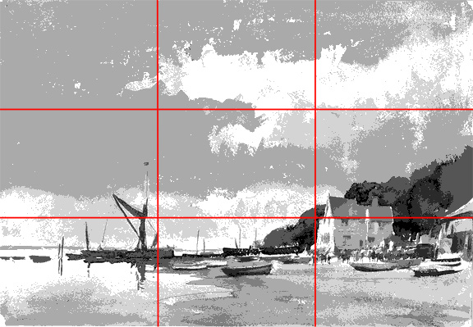

This is a typical coastal view by Edward Seago. The horizon line is positioned about one-quarter of the way up the canvas - a division of land (or water) and sky which is quite common in marine and landscape subjects. Raising the horizon so that it aligns with the lower horizontal line of the grid would compromise the artist’s intention which is to emphasise the sense of scale and drama provided by the sky.

Are there any other alignments? The mast of the boat on the left lies close to the left vertical grid line and the gable end of the building on the right is adjacent to the lower right intersection. Both of these elements show strong value contrast with their surroundings and both act as focal points; the lit face of the building is probably the dominant focus.

No conclusions at this point; one example proves nothing either way.

The next image is also by Seago. The subject matter is similar.

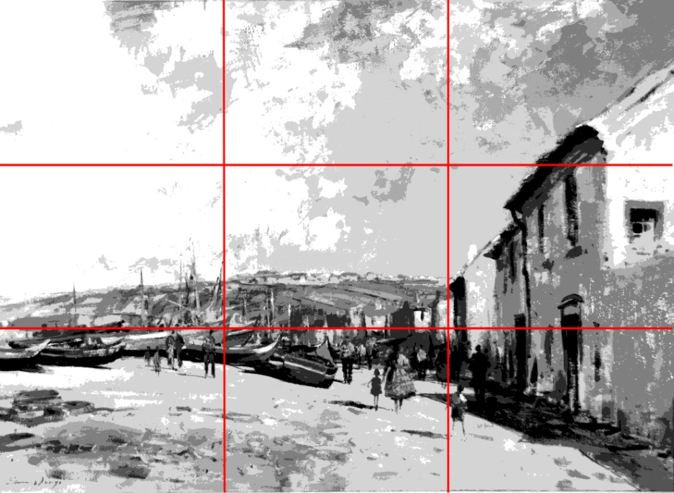

Here, there is a better correspondence between the lower horizontal grid line and the busy section of the painting with its boats, buildings and figures. The woman and child in the foreground are probably the primary focal point but they lie some distance from the nearest intersection point. A secondary focus might be the group of figures next to the lower left intersection.

But there is nothing to suggest any definite concurrence between the grid and the composition.

The next painting is by John Singer Sargent.

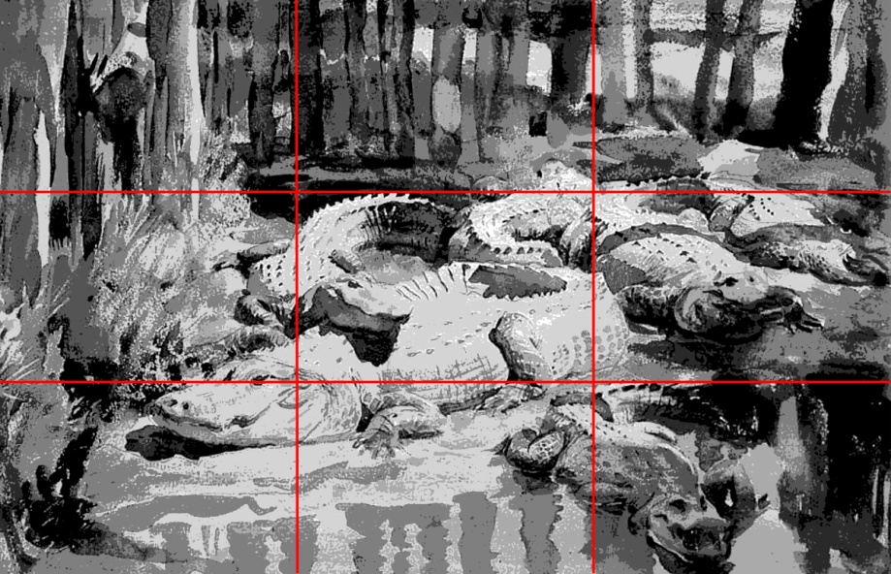

There is a rough division into thirds in this example with the subject split into trees, alligators and water (although one of the alligators has invaded the water section). The eye of the biggest alligator – surely the focal point - is aligned perfectly with the lower horizontal grid line and is close to the intersection; the head straddles the intersection.

Correlation here is pretty good.
This is another Sargent example,

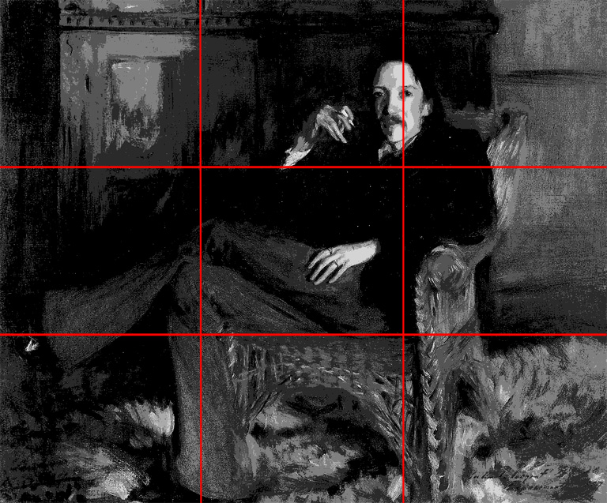

The head of the sitter (Robert Louis Stevenson) is aligned with the right vertical grid line but well above the intersection. Although the hands are subsidiary focal points (because of value contrast), they show no relationship to the grid.

The sitter’s lower right leg corresponds well with the left vertical grid line while the side of the chair is close to the right vertical.

Overall, there is very little correspondence.

Here’s a third Sargent subject,

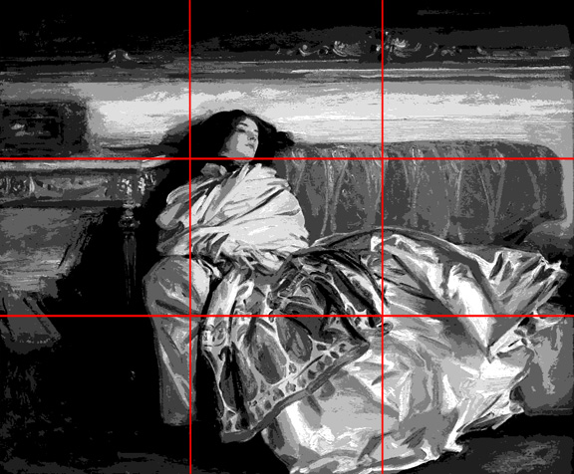

The table top and couch back align closely with the upper horizontal gridline; the head – the focal point -is just above it and to the right of the left intersection. The right side of the figure and couch correspond well with the left vertical.

There is some agreement between grid and composition, but not enough to preclude chance.

These two paintings, the first by Sargent again, the second by Quang Ho, are examples of pleasing arrangements which fail to show any unambiguous relationships to the Rule of Thirds grid.

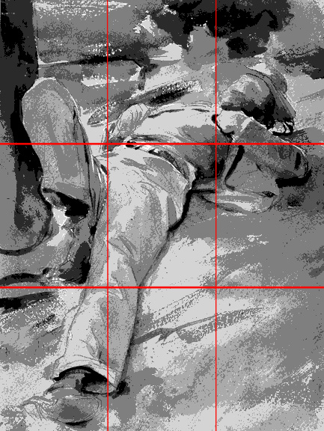

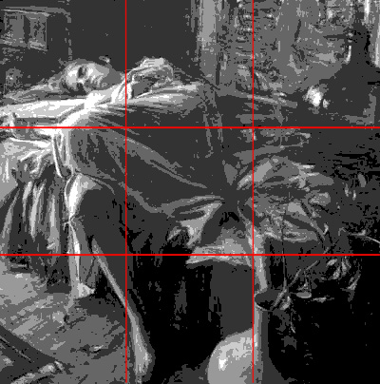

I’ve looked at a number of other paintings by various artists and the results are always the same: either negative or inconclusive. So does this invalidate the Rule of Thirds as a compositional tool? Not necessarily, it simply suggests that master painters compose their works in more varied and imaginative ways than Rule of Thirds allows.

However, even if composition-by-grid does work, it does raise some questions about its effectiveness.

First of all, does it represent a complete compositional system? The answer to this has to be ‘No’ – at least for the painter who, unlike the photographer, has to create his composition from scratch. For example, creating a focal point requires more than simply aligning an element of subject matter with a point of intersection. A focal area must contrast with its surroundings, it must dominate other competing sections of the painting; it may involve the organization of other elements to create directional cues – movement , linear perspective – to drive the eye to it. At best, it’s only a partial solution.

A more fundamental question is: ‘Does Rule of Thirds represent a compositional system at all?’ There is a danger in using a grid that it becomes a rigid compositional formula rather than an adaptable method or process. The result would be predictable, monotonous designs – much like the results of painting objects like trees and skies and water in a formulaic, mannered way.

Several useful compositional ideas emerged as a by-product of these exercises in Rule of Thirds. This painting by Seago illustrates one of them:

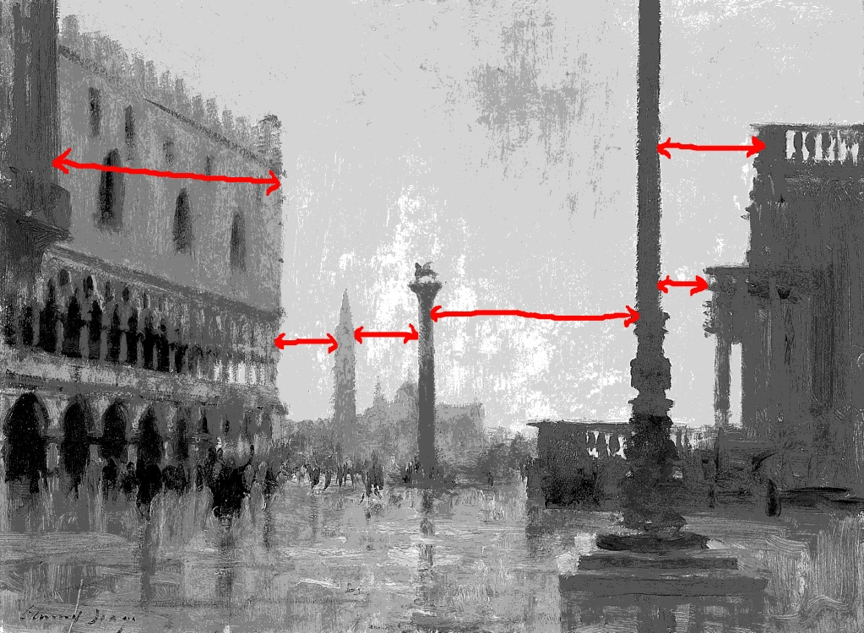

The intervals between the main vertical elements in the painting – from left to right, the Doge’s palace, the spire in the distance, the columns and the building on the right – are all different. Making the intervals different while preserving the balance of the composition adds visual interest to the painting. This is an important design principle and it applies not just to the spaces between elements, it also works with other properties such as value, colour and size. Seago has used this principle of variety to create a beautifully balanced work. I’ll return to the topic of design principles later.

notan

Notan is a term that crops up quite often these days in articles on composition. It is a Japanese concept that was popularized by Arthur Wesley Dow in his book ‘Composition – Understanding Line, Notan and Colour’ published in 1920.

A notan drawing is a two-value or two-tone interpretation of a subject. Here’s an example:

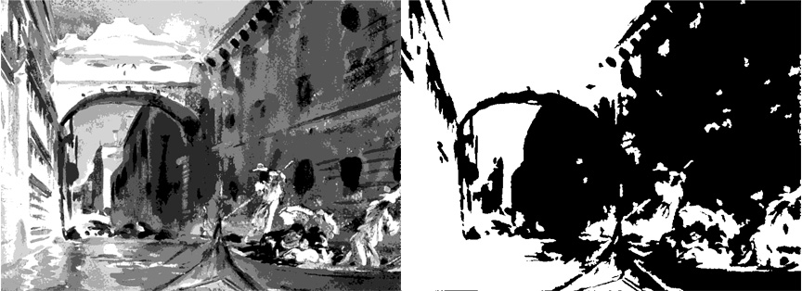

On the left is a posterised version of the Sargent watercolour, ‘Bridge of Sighs’; on the right is a notan interpretation of the painting created in Photoshop using the Threshold option which reduces a full-value image to a black-and-white one. A threshold value is selected and all values at or below that level are made black while all values above it are made white.

What information do you get from a notan study?

The main idea is to subordinate the subject matter to the abstract design of the work. The process merges individual forms into shape-value masses, sacrificing detail. The aim is to produce a value pattern between the black and white areas that is compositionally balanced. However, the problem then is, what do you do next?

Notan does not offer any help in re-establishing multi-value structure to the black and white areas which (unless you intend to produce a two-value finished painting) will have to be done. Notan doesn’t explicitly create a focal point; it tells us nothing about the elements of line or colour; and there are no gradations or textures. Notan studies are much easier to create if you have access to Photoshop.

elements and principles of design

The most comprehensive and rigorous approach to composition is embodied in the various interpretations of the elements and principles of design. This will be the subject of the next post.

Although there is an academic feel about many of these accounts, there are variations in the terminology and definitions of the elements and principles from one source to another; three versions by Edgar Whitney, Nancy Doyle and Charlotte Jirousek illustrate this variability.

Whitney identifies seven design elements: line, value, colour, shape, size, texture and direction. Doyle’s list also consists of seven elements: mark, line, colour, value, shape, texture and space; she doesn’t include size or direction and she adds mark and space to Whitney’s list. Jirousek’s list includes point, line, form+shape+space, movement, colour+value, pattern and texture. She regards value along with hue as a component of colour; point is synonymous with Doyle’s mark. She treats form and space or shape and space as complementary, mutually defining elements. The addition of movement is unusual; it’s normally regarded as a design principle rather than an element.

Whitney’s inclusion of direction in his list is typical of the confusion that surrounds the definition and description of these elements and principles. By direction he means direction of line – which to me would be best regarded as a property of the line element rather than as an element in its own right. In a similar way, line, colour, shape and texture always have a property of value. However, value is almost always identified as a separate element. (Aside: In an article in the International Artist magazine, American artist Scott Christensen describes how he breaks his subject down into a series of value-shapes.)

It’s a similar story with the design principles. Whitney lists eight: balance, conflict, harmony, dominance, gradation, alternation, repetition and unity. Doyle also has eight: balance, contrast, harmony, emphasis, movement, proportion, variety and unity. Jirousek, however, identifies only five: balance, emphasis, rhythm, proportion and unity.

This inconsistency in terminology extends to the definitions and descriptions of the elements and principles. In Whitney’s description of his principles, he equates conflict to contrast and gradation to movement. Jirousek includes gradation, alternation and repetition as examples of rhythm. With the possible exception of contrast (which is implied in emphasis and/or variety), Doyle’s list is probably more typical than the other two.

With the help of various sources, I’ll try to define each of these design principles.

balance

‘Balance is the result when forces opposing each other are equal.’ (Whitney)

‘Balance is the concept of visual equilibrium... It is a reconciliation of opposing forces in a composition that results in visual stability.’ (Jirousek)

‘The most visually satisfying solution is to have a dominant element balanced by a minor supporting element.’ http://designelementsandprinciples.com/balance2.htm

Most accounts distinguish three kinds of balance:
- symmetrical or formal
- asymmetrical or informal
- radial
Symmetrical balance is also described as static and is typified by many pre-Renaissance religious paintings. Asymmetrical balance is dynamic and is the usual form of balance in representational works.

‘While symmetry achieves balance through repetition, asymmetry achieves balance through contrast.’ (Donna Tersiisky)

The analogy of a beam balance or see-saw occurs in several definitions of this principle. The concept of visual weight which Jirousek mentions is nicely elaborated by Tersiisky who identifies ten design elements or properties of elements which exert visual weight. These are position, size, texture, isolation, value, value-contrast, number (quantity), orientation, shape and colour. In each case, visual weight of an element is increased by the action specified:

- Position – move away from centre
- Size – make larger
- Texture – make more complex
- Isolation – move further away from other elements
- Value – make darker
- Value-contrast – increase value-contrast
- Number – balance single large object with multiple smaller ones
- Orientation – arrange elements diagonally rather than horizontally/vertically
- Shape – make more complex
- Colour – increase brightness and intensity.

Rhythm

‘Rhythm is...created by repeating visual elements (lines, shapes, forms, etc…) in a regular beat or order.’ (Linda Vining)

Whitney doesn’t explicitly list rhythm itself as a design principle but he does include the three forms of rhythm which Jirousek and others describe. These are repetition, alternation and gradation. Repetition (or regular rhythm) at its simplest is a sequence of identical design elements (motif) separated by regular intervals - in effect, a pattern. Repetition needs variety to avoid monotony. A series of identical windows in the facade of a building, for example, can be varied by showing some open, some closed; some with shutters, some without; some in darkness, some lit.

Alternation is similar to repetition except the repeating unit is a set of elements which contrast in some way – dark and light, large and small, for example.

Gradation (or progressive rhythm) is a sequence of gradual change in an element, suggesting movement. An example might be a line of fence posts progressively diminishing in size in a landscape. In this case, gradation equates to linear perspective.

Several sources, including Jirousek and Vining, include a fourth type of rhythm, linear or flowing rhythm.

‘Linear rhythm refers to the characteristic flow of the individual line.’ (Jirousek)

I think this is defining linear rhythm as a stylistic quality of a particular artist.

‘A flowing rhythm is a graceful path of repeated movements.’ (Vining)

Since Vining includes progressive rhythm in her list of principles, flowing here is not synonymous with gradation. I’m guessing it means some form of linear rhythm.

Vining also mentions a fifth form, jazzy rhythm, which she defines as repeating ‘the art elements in complicated and unexpected ways’.

Rhythm is one of the most variably defined of the design principles in the descriptions I’ve looked at; Tersiisky and Whitney don’t include it in their lists at all. There is also a degree of overlap (confusion?) of rhythm with movement and pattern.

emphasis

‘Emphasis...marks the locations in a composition which most strongly draw the viewers attention... The emphasis is usually an interruption in the fundamental pattern or movement of the viewer’s eye through the composition, or a break in the rhythm.’ (Jirousek)

Emphasis is the process of creating a focal point in a painting. The usual method of achieving this is to create or enhance contrasts between elements and properties of elements in the region of focus. Examples include contrasts of value, colour, shape and texture. Contrasts may be combined to increase emphasis: value and colour contrasts are often used together.

movement

Movement is typically defined as the arrangement of design elements to direct the eye along specific paths in the composition - often to the focal point. Jirousek (who classifies movement as an element rather than a principle) identifies two types of movement: static and dynamic. Static movement involves jumping from element to element and is ‘characterized by repetition of closed, isolated shapes and contrasts of colour and/or value’. Dynamic movement, on the other hand, is smooth, ‘guided by continuations of line or form, and by gradations of colour or form’ and ‘characterized by open shapes’.

This idea of smooth and staccato versions of movement adds to the blurring of the boundary between the definitions of movement and rhythm.

harmony

‘Harmony is achieved when two or more of a unit’s components are similar.’ (Whitney)

Whitney goes on to give a fairly precise account of what he considers to be harmony. A circle and an oval are harmonious shapes; a circle and a triangle aren’t. Blue and green are harmonious; a saturated blue and yellow aren’t. He differentiates harmony from unity:

‘Equal areas and intensities of red and purple would be disunity although the colours are harmonious.’

He relates harmony and gradation by pointing out that, although the extreme elements of a gradation may be ‘in violent contrast’, adjacent elements in such a transition are harmonious. He gives the example of a series of straight lines ‘falling’ from the vertical to the horizontal.

By Whitney’s definition, harmony is the opposite of contrast; the harmonious parts of a painting will be the ‘quiet’ areas. In that sense, harmony, like space, is a negative concept – which may partly account for its omission by most sources as a design principle.

variety

Variety was mentioned earlier in connection with repetition: variations in repeated elements avoid monotony and help keep the viewer interested. Variety applies to all of the design elements.

One source includes variety and contrast as separate design elements: contrast is described as a ‘large difference between two things’, while variety is ‘achieved by using opposites or strong contrasts’. Variety, in effect, is just another word for contrast (or conflict or opposition). Most sources don’t include variety as a design principle.

proportion

‘Proportion refers to the relative size and scale of the various elements in a design.’ (Jirousek)

‘Proportion in art is the comparative harmonious relationship between two or more elements in a composition with respect to size, colour, quantity, degree, setting, etc.; i.e. ratio.’ (Teresa Bernard)
http://www.bluemoonwebdesign.com/art-lessons-7.asp

Proportion as a design principle is not concerned with the proportions of objects like people or architecture. Questions such as ‘Are the anatomical proportions of this figure correct?’ and ‘Is the perspective of this building accurate?’ have more to do with technique than design. Proportion is properly about the whole work; do the main divisions of the piece (in terms of colour, value, shape etc.) relate harmoniously? As a general rule, the division of elements should be unequal to avoid monotony.

contrast

Contrast was mentioned earlier as a way to achieve emphasis. Probably the strongest contrasts are created with value and colour. Here are some possible contrasts:

- Contrast of value or tone (light against dark)
- Contrast of hue (blue against orange, green against red)
- Contrast of intensity (saturated against grey)
- Contrast of tonal key (high versus low, full versus restricted)
- Contrast of edge definition (blurred versus sharp, “lost-and-found”)
- Contrast of line (straight versus curved, etc.)
- Contrast of texture (thin versus impasto, opaque versus transparent)
- Contrast of size (small dark versus large light, small saturated versus large grey)

dominance

According to Whitney, dominance ‘resolves conflict and regains unity’; it does so most often through ‘repetition of an element or elements of design’. Looking at his examples, the principle essentially means making sure that there is always an imbalance – in terms of number or size, for example – between contrasting elements. So if a design consists of an arrangement of horizontal and vertical lines, to achieve dominance there should be more horizontal than vertical or vice versa. Alternatively, one set of lines could be made heavier (thicker) or darker in value than the other set.

In some sources, dominance is synonymous with emphasis and the definition of a focal point.

unity

Unity is a difficult principle to nail down. It implies that the principles – balance, rhythm, emphasis etc. - have been used successfully to integrate all of the elements in a painting. Nothing appears out of place. Unity extends to the appropriateness of the design to the content or meaning it is intended to convey. Does the mood of the work, for example, reflect what the artist is trying to communicate?

Whitney regards an artist’s style as a factor in creating unity. Technique, too, ‘can unify works by repetition of the character of marks or means employed’.

This resource offers an excellent and comprehensive description of unity.
http://www.slideshare.net/rngy/principles-of-design-11350230

Why should this be? And is there a way to go about the business of composition systematically?

